React.js Component Creation

Name : Ponnekanti Bhavana lakshmi

Email : lakshmibhavana37@gmail.com

Phone No : 7032054615

Roll NO : 21NN5A0505 (CSE)

College Name : Vignan’s Nirula Institute of Technology and Science for Women

source code :

CARD COMPONENT :

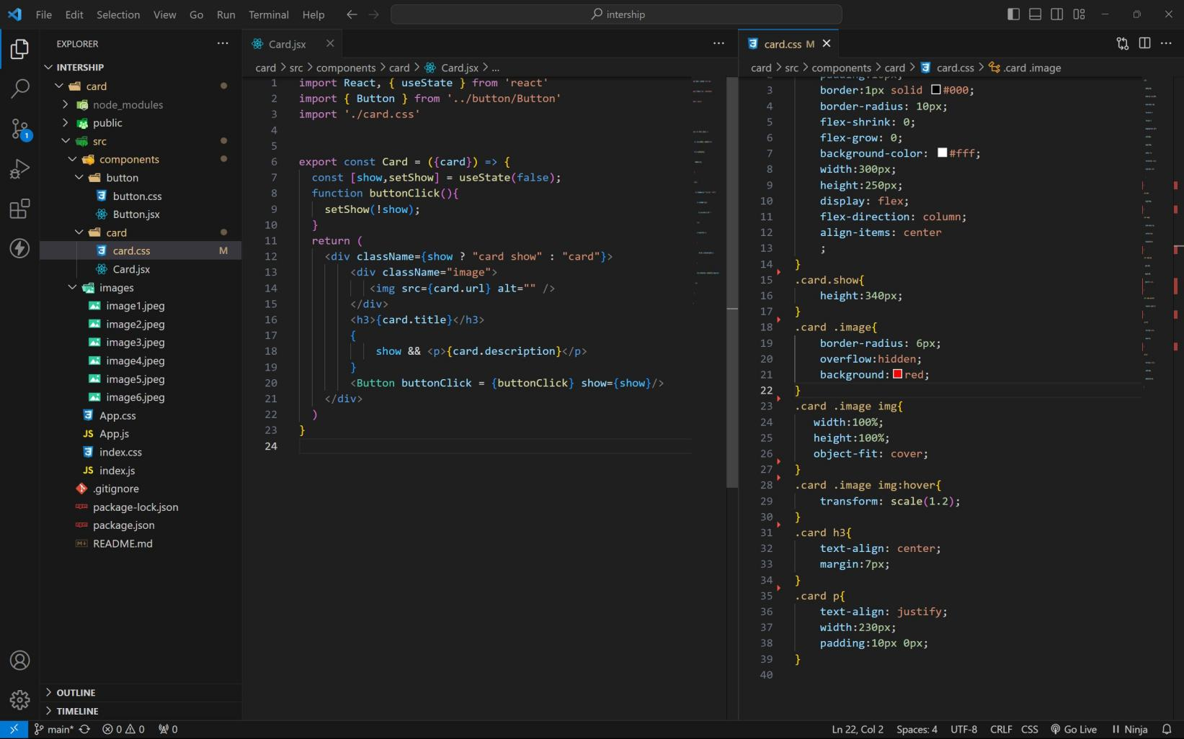

BUTTON COMPONENT :

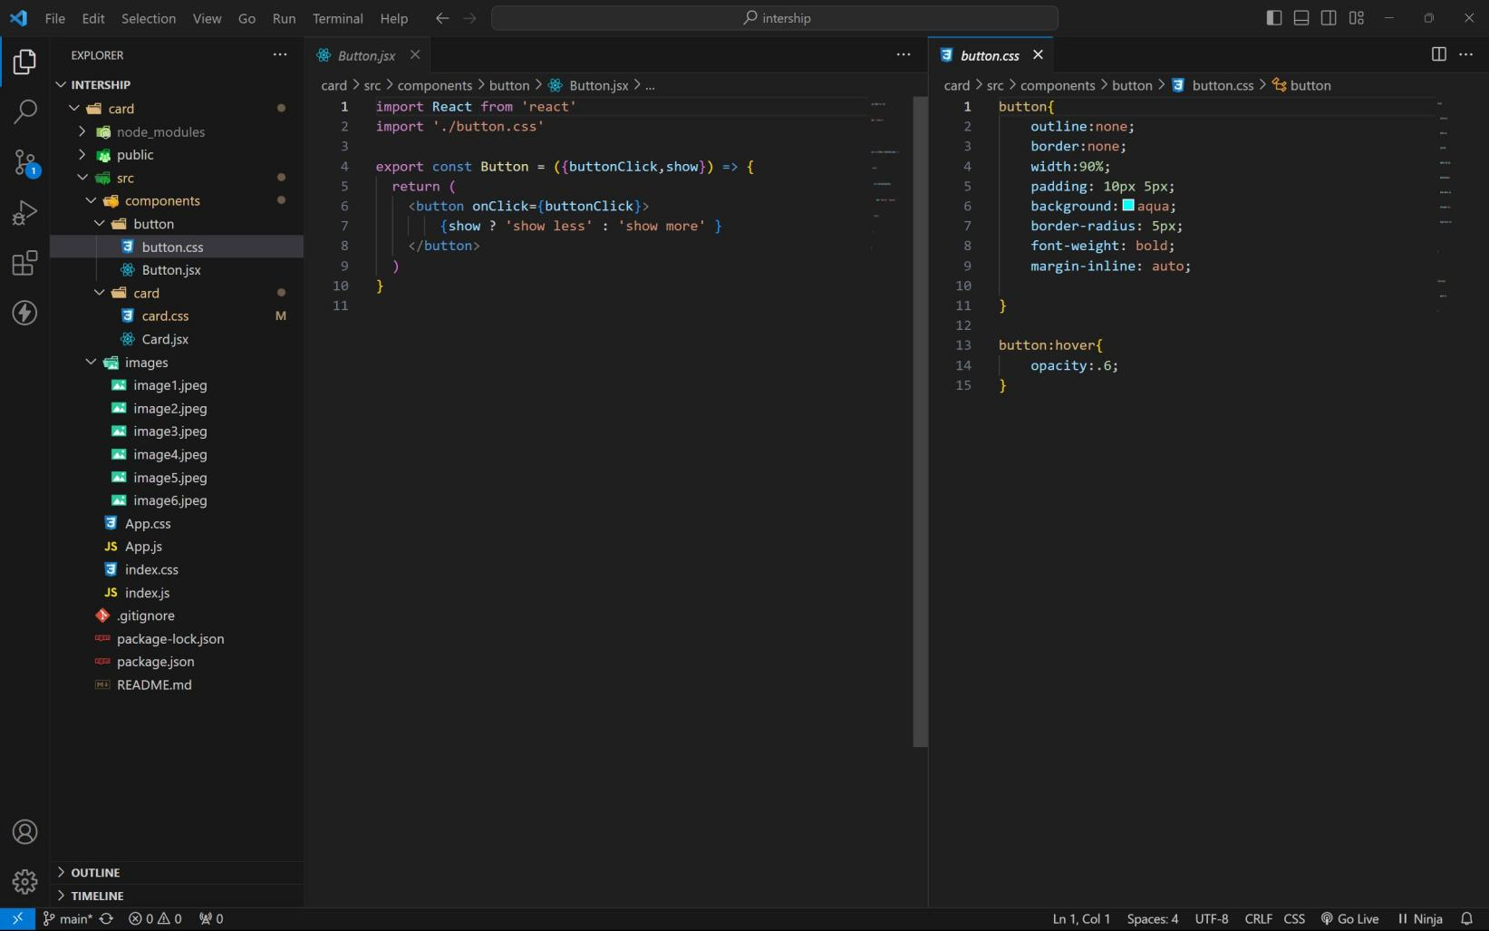

APP COMPONENT :

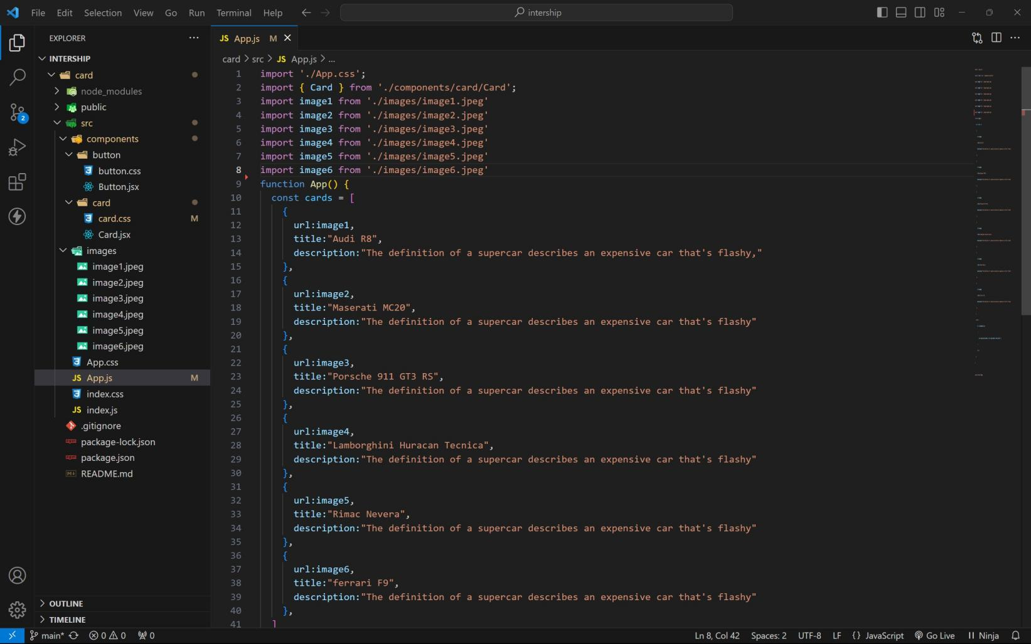

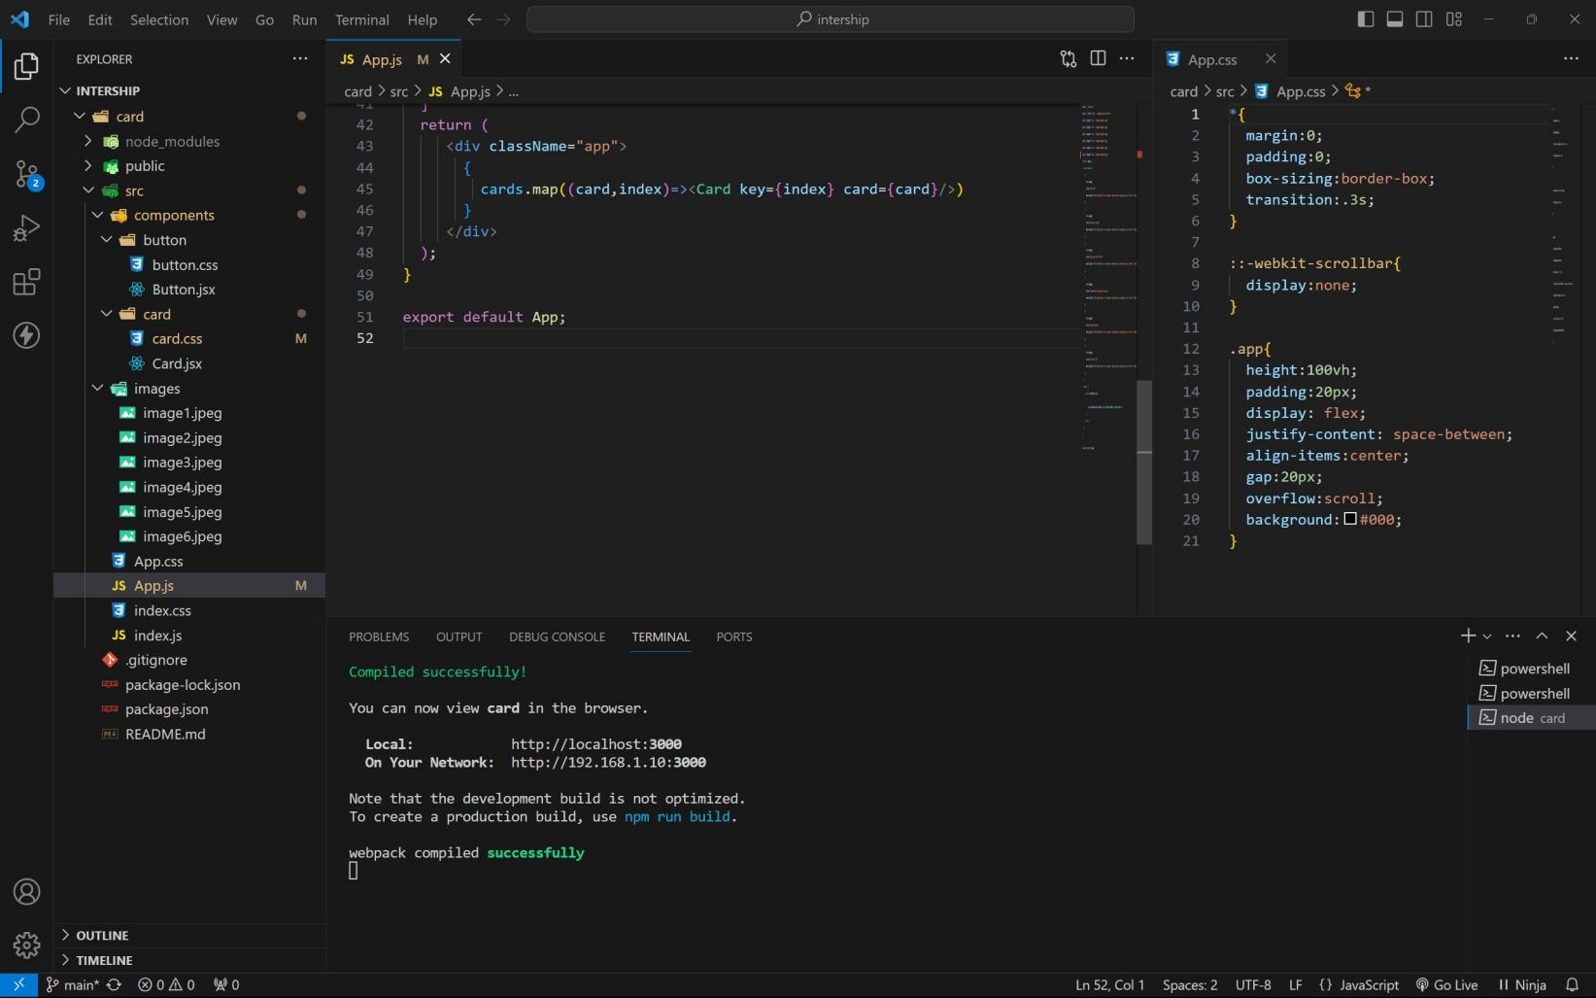

approach :

1. initially taking an array of objects like below

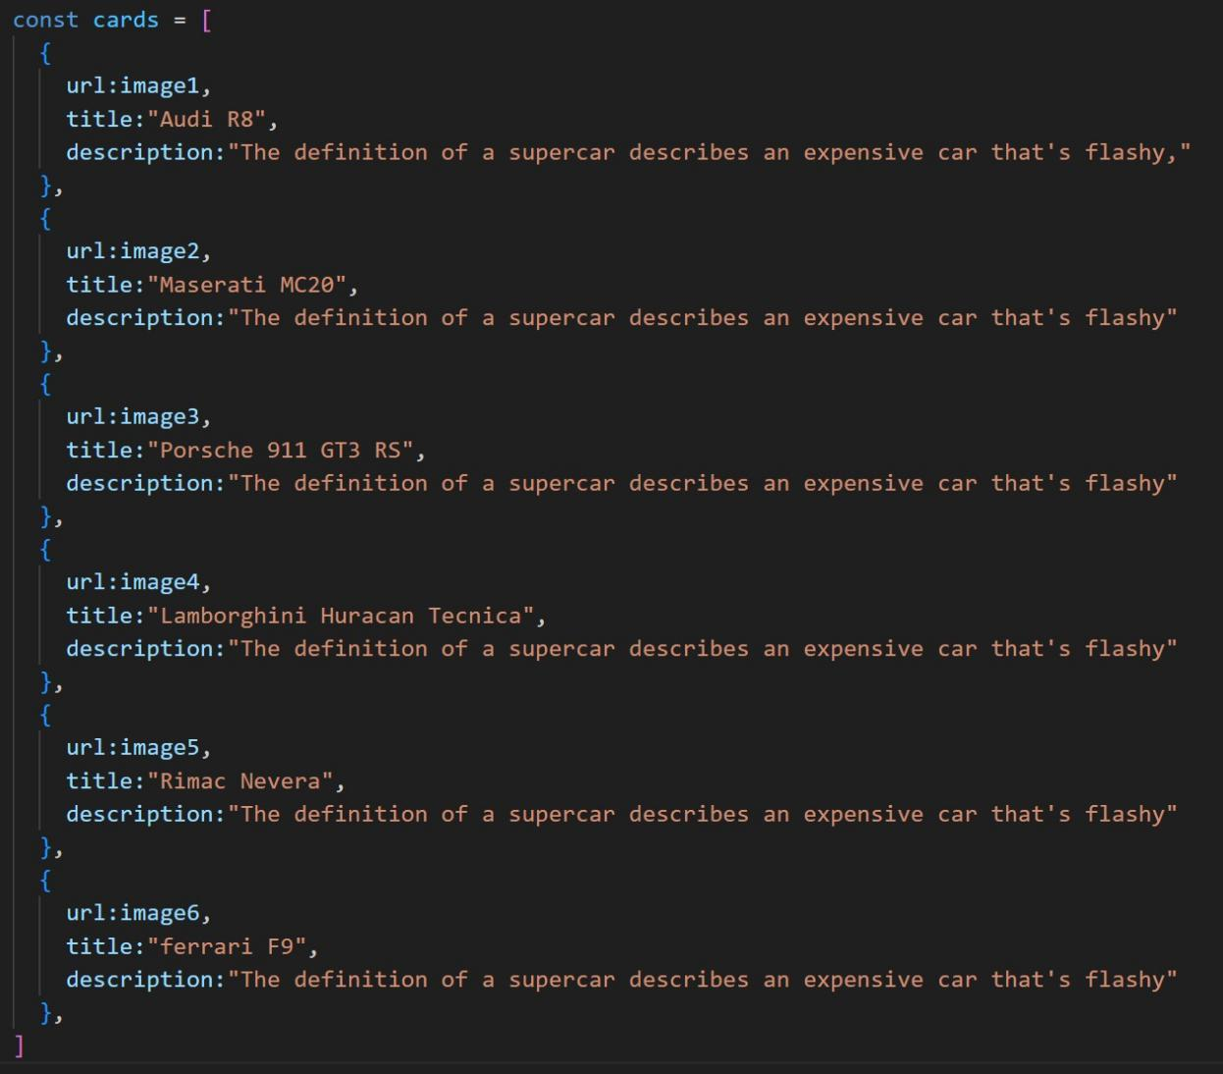

1. Passing this card array to child (card component) of App component by using props;
2. getting data as argument like {card} in card component.
3. in card component i use one state [show, setShow] to get extra info as description.
4. When we click the button then show becomes true by assigning setShow (!show) .

OUTPUT :

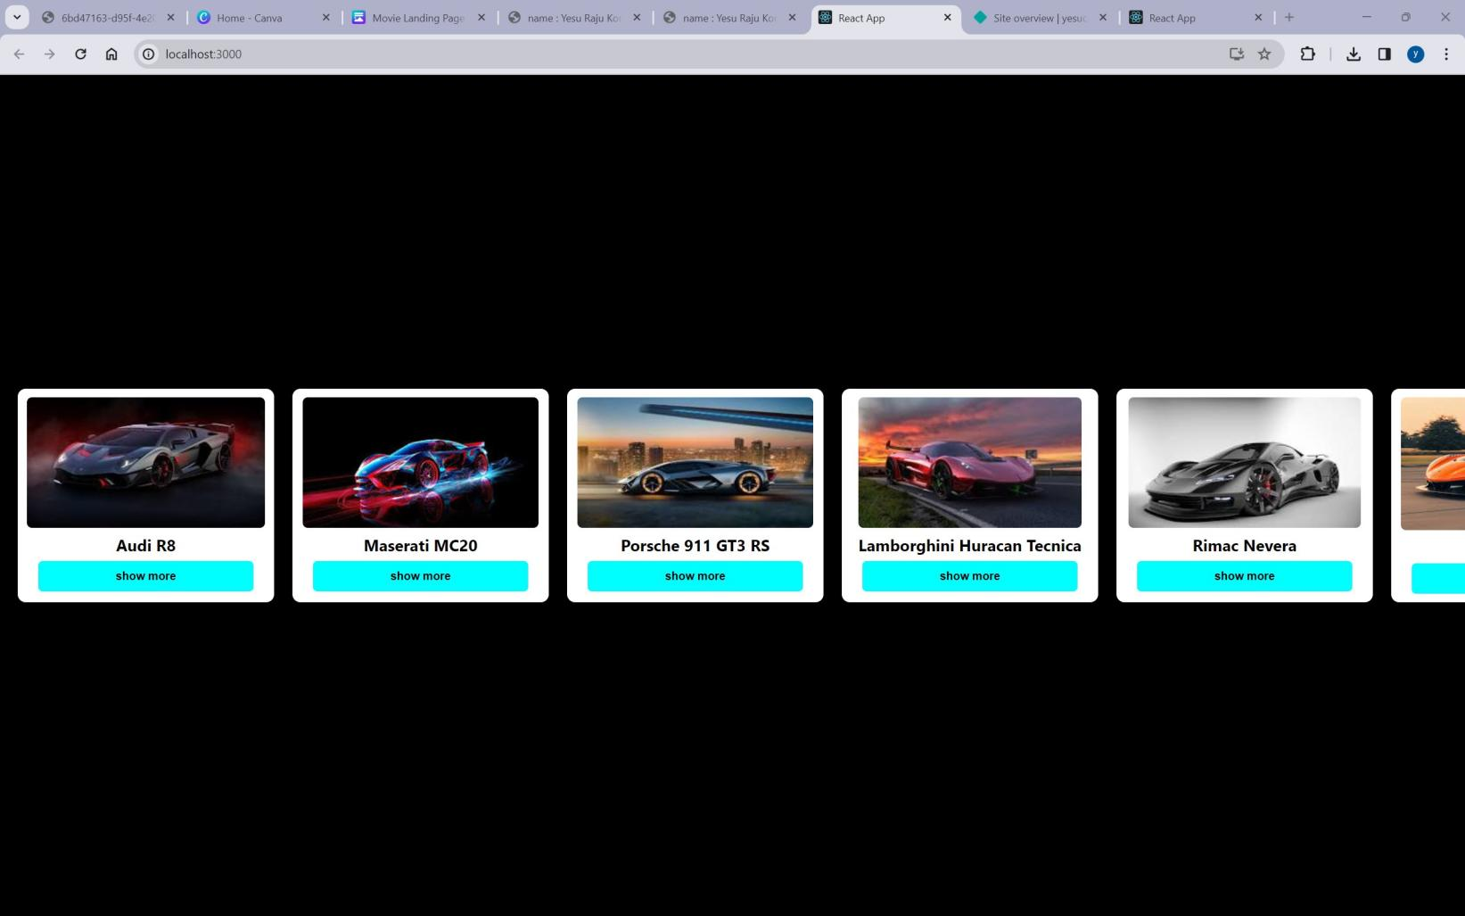

AFTER BUTTON CLICKS :

